1. **Methodology:**

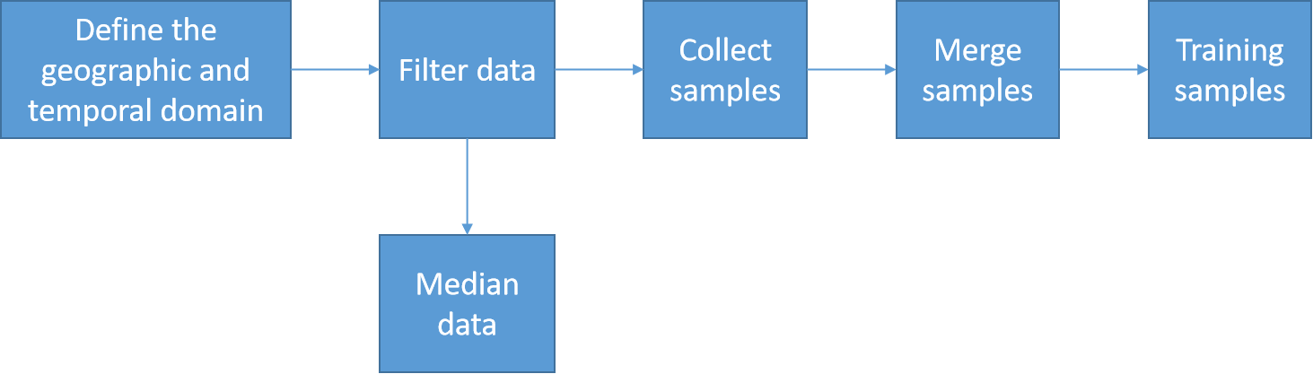

**Define geographic and temporal domain**: choosing the area of interest and it temporal data.

**Filter data**: get the length of date of the data. We choose from March to August which in dry season to avoid cloudy.

**Median data:** take median all the input Landsat image.

**Collect samples:** collect training data to teach the classifier, collect representative samples of reflectance spectra of each land cover class of interest; assign collected data to each class that represent for its characteristic.

**Merge samples:** merge those class into a single collection, called a FeatureCollection.

**Training data:** apply the classifier algorithm to train the data.

1. **Procedure:**

- First we sample the region of interest by points.

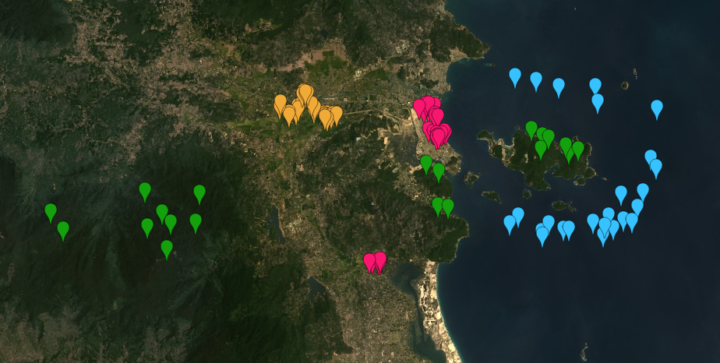

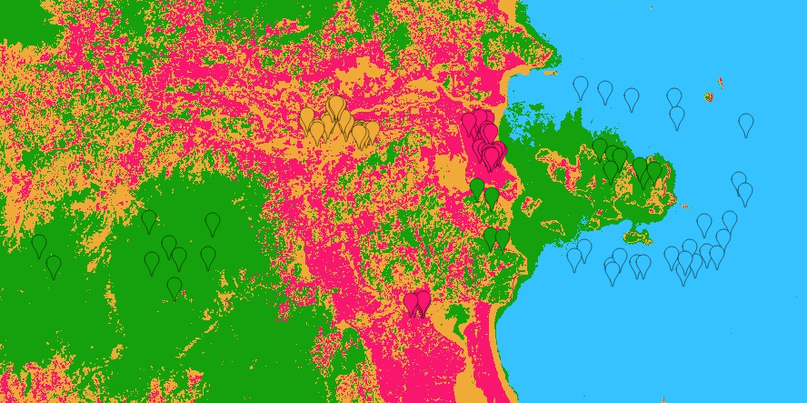

|  |  |  |  |
| --- | --- | --- | --- |
| Urban | Forest | Water | Agriculture |

*Nha Trang City - 2016*

The result contain many false classifications. Especially, the mix region between urban and agriculture. There are a few option to improve this classification:

+ Change the training sample size: use polygons instead of points for more training pixels.

+ Change the sampling strategy: some land cover class cover much more area than others. We could experiment with a stratified sampling approach instead.

+ Change the algorithm: try different algorithm to approach the classification.

Thus, in next step we combine points and polygon sampling.

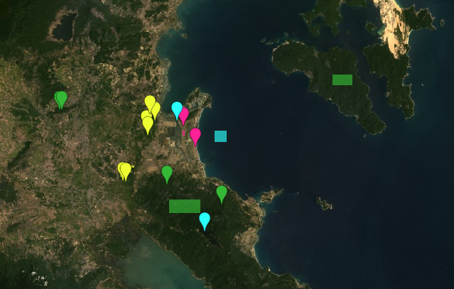

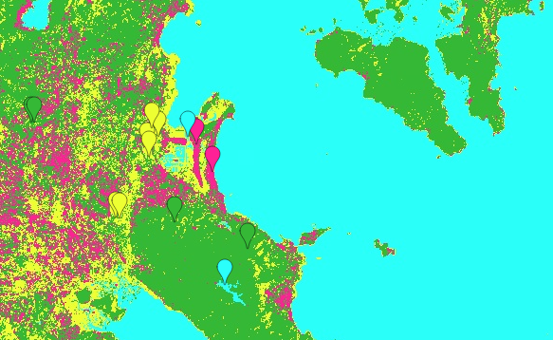

|  |  |  |  |
| --- | --- | --- | --- |
| Urban | Forest | Water | Agriculture |

*Nha Trang City - 2016*

This result still contain the mixing-false region of urban and agriculture, also on the island areas. Let try to use only polygon sampling.

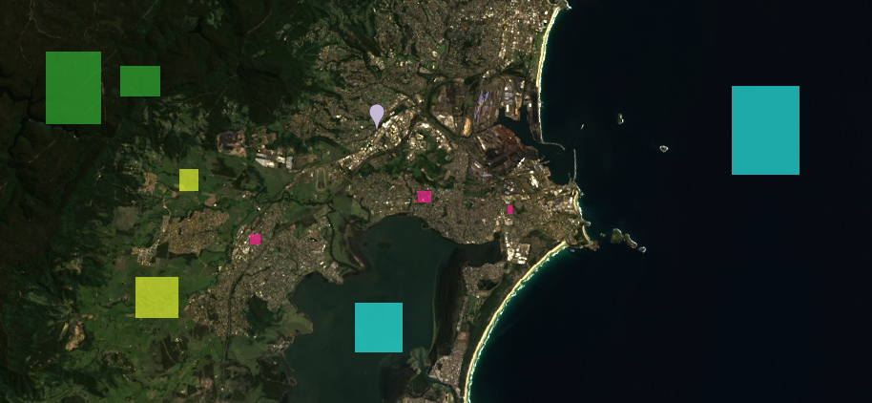

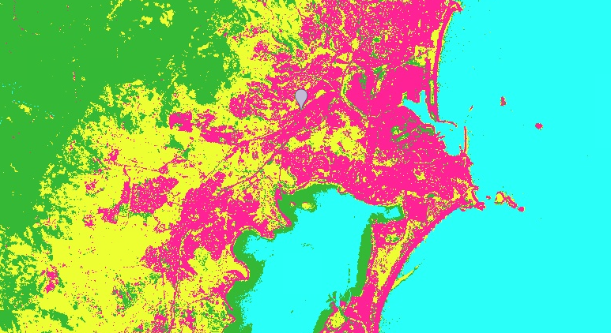

|  |  |  |  |
| --- | --- | --- | --- |
| Urban | Forest | Water | Agriculture |

*Nha Trang City - 2016*

Now the classification get more accurate. Next we use different algorithm to decide which one is suitable for our work.

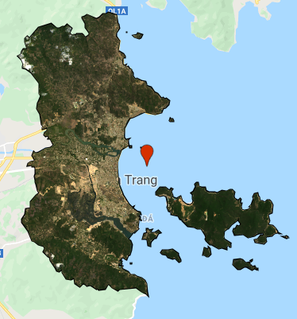

|  |  |  |  |
| --- | --- | --- | --- |
| Urban | Forest | Water | Agriculture |

*Nha Trang City - 2015*

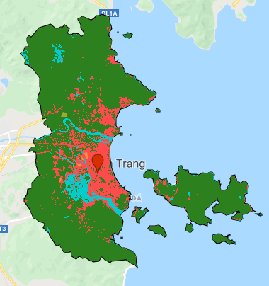 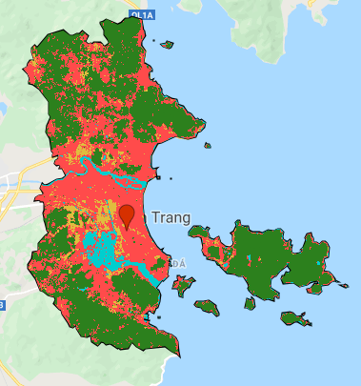

*perceptron() svm()*

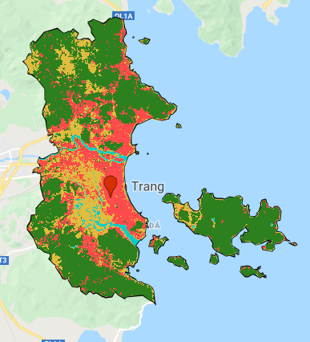 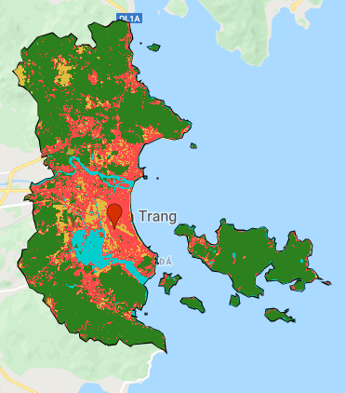

*naiveBayes() minimumDistance()*

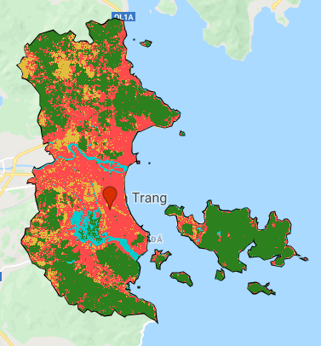 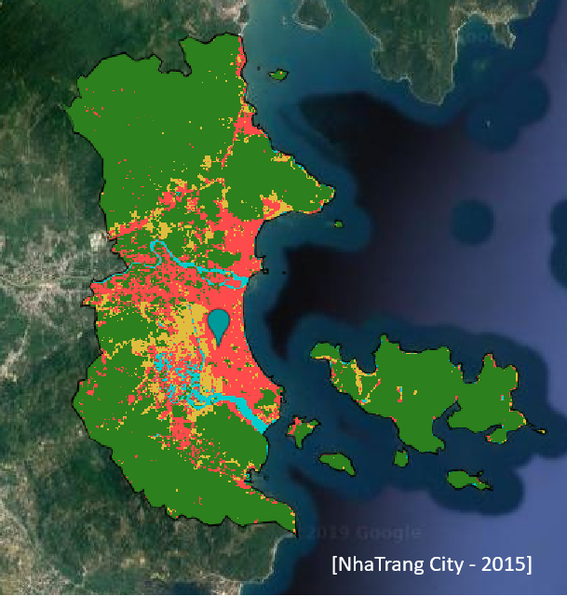

*cart() gmoMaxEnt()*

Those result are list in evaluated order from left to right/ top to bottom. From the real image we clarify that the gmoMaxEnt() algorithm is the most pertinent algorithm for our classification.

1. **Result:**



|  |  |  |  |
| --- | --- | --- | --- |
| Urban | Forest | Water | Fallow |

*Nha Trang City*

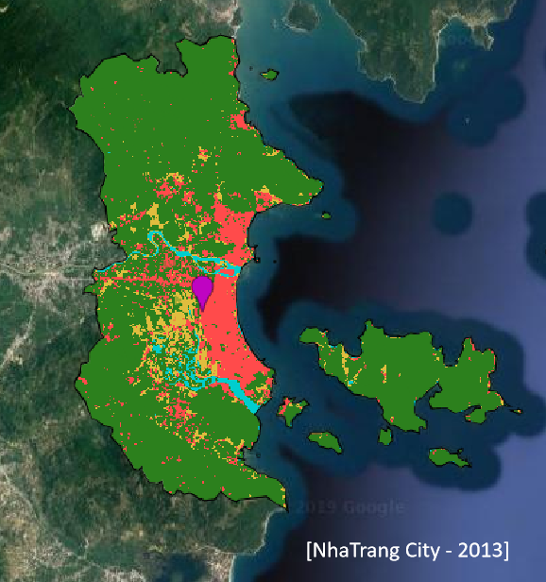

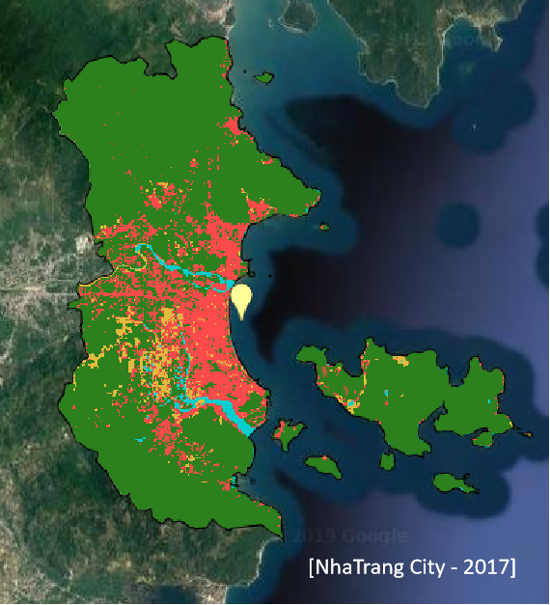

From the results, we can recognize the urban area spread to the West from 2013 to 2015.

In 2015, the fallow area near the center of the city was expanded in quantity, then being filled slightly by urban area in 2017. In fact, this result fit to the urbanized status of Nha Trang City. Those fallow and bare soil, at first, are the replacement of agriculture area, they were prepared to construct households also resorts due to the overgrown of population and traveling service.